

**Veermata Jijabai Technological Institute, Mumbai 400019**

**Experiment No.:** 04

**Aim:** Study of Decision Trees and other classification Algorithms.

**Name:** Kiran K Patil

**Enrolment No.:** 211070904

**Branch:** Computer Engineering

**Batch:** D

**Theory:**

A thorough study of decision trees and other classification algorithms is crucial in the field of machine learning and data science. These algorithms play a pivotal role in solving classification tasks, where the goal is to assign data points to predefined categories or classes. Let's delve into a detailed study of decision trees and several other notable classification algorithms:

**1. Decision Trees:**

**Overview:**

* Decision trees are versatile and interpretable machine learning models used for classification and regression tasks.
* They represent decisions and their possible consequences in a tree-like structure.
* At each internal node, a decision is made based on a feature, and branches represent possible outcomes.
* Leaf nodes correspond to the predicted class or value.

**Advantages:**

* Easy to understand and interpret, making them valuable for explaining decision logic.
* Capable of handling both categorical and numerical data.
* Prone to overfitting, but techniques like pruning can help mitigate this.

**Use Cases:**

* Disease diagnosis in healthcare.
* Credit scoring in finance.
* Customer churn prediction in marketing.

**2. Random Forest:**

**Overview:**

* Random Forest is an ensemble learning method that combines multiple decision trees.
* It creates a forest of trees and aggregates their predictions to improve accuracy and reduce overfitting.

**Advantages:**

* High prediction accuracy due to the combination of multiple trees.
* Robust against overfitting.
* Suitable for high-dimensional and large datasets.

**Use Cases:**

* Image classification.
* Fraud detection.
* Natural language processing.

**3. Support Vector Machines (SVM):**

**Overview:**

* SVM is a powerful classification algorithm that finds the optimal hyperplane to separate classes.
* It can handle both linear and nonlinear classification tasks using appropriate kernels.

**Advantages:**

* Effective in high-dimensional spaces.
* Can work well with small to moderate-sized datasets.

**Use Cases:**

* Image recognition.
* Text categorization.
* Protein classification in bioinformatics.

**4. k-Nearest Neighbours (KNN):**

**Overview:**

* KNN classifies data points based on the majority class among their k-nearest neighbours in feature space.
* It's a non-parametric, instance-based algorithm.

**Advantages:**

* Simple and easy to implement.
* Non-parametric nature is suitable for data with unknown or complex distributions.

**Use Cases:**

* Recommendation systems.
* Anomaly detection.
* Handwriting recognition.

**5. Naive Bayes:**

**Overview:**

* Naive Bayes is a probabilistic classifier based on Bayes' theorem with the "naive" assumption of feature independence.
* It's especially suited for text and document classification.

**Advantages:**

* Simple and computationally efficient.
* Performs well when the independence assumption holds or is close to true.

**Use Cases:**

* Sentiment analysis.
* Document categorization.
* Email spam filtering.

A comprehensive study of these classification algorithms involves understanding their underlying principles, strengths, weaknesses, and the scenarios in which they are most effective. It also includes practical experience in implementing and fine-tuning these algorithms on real-world datasets.

Successful application of these algorithms often hinges on careful model selection, preprocessing of data, feature engineering, and rigorous evaluation techniques. Additionally, machine learning practitioners should be well-versed in interpreting and communicating the results to stakeholders, as model transparency and explain ability are essential in many domains.

**Implementation**

**Decision tree implantation**

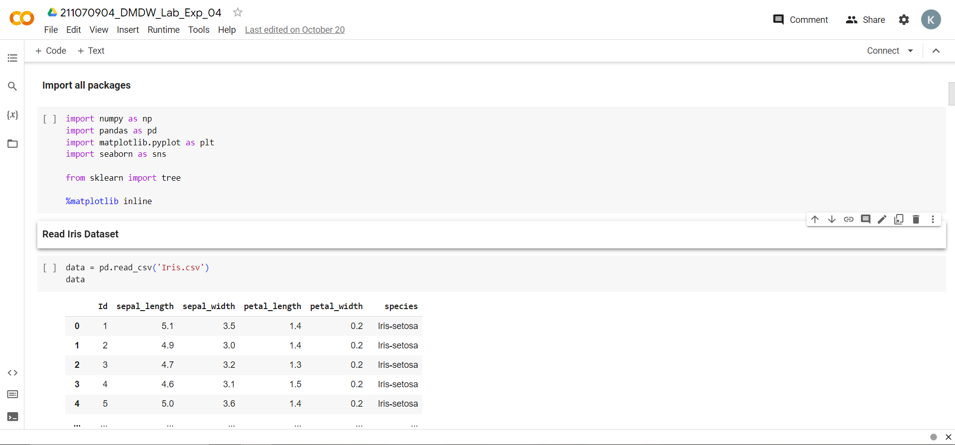

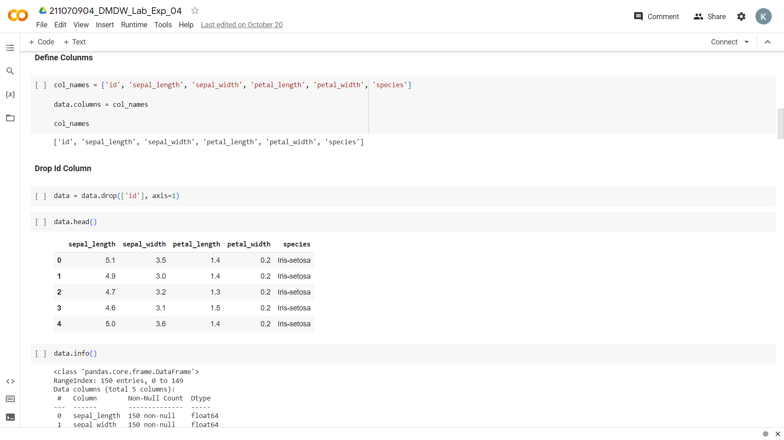

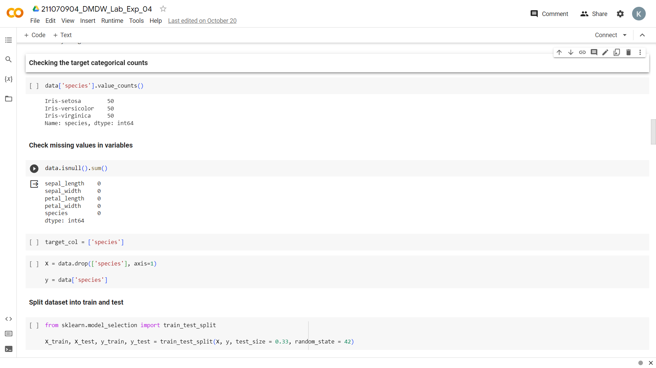

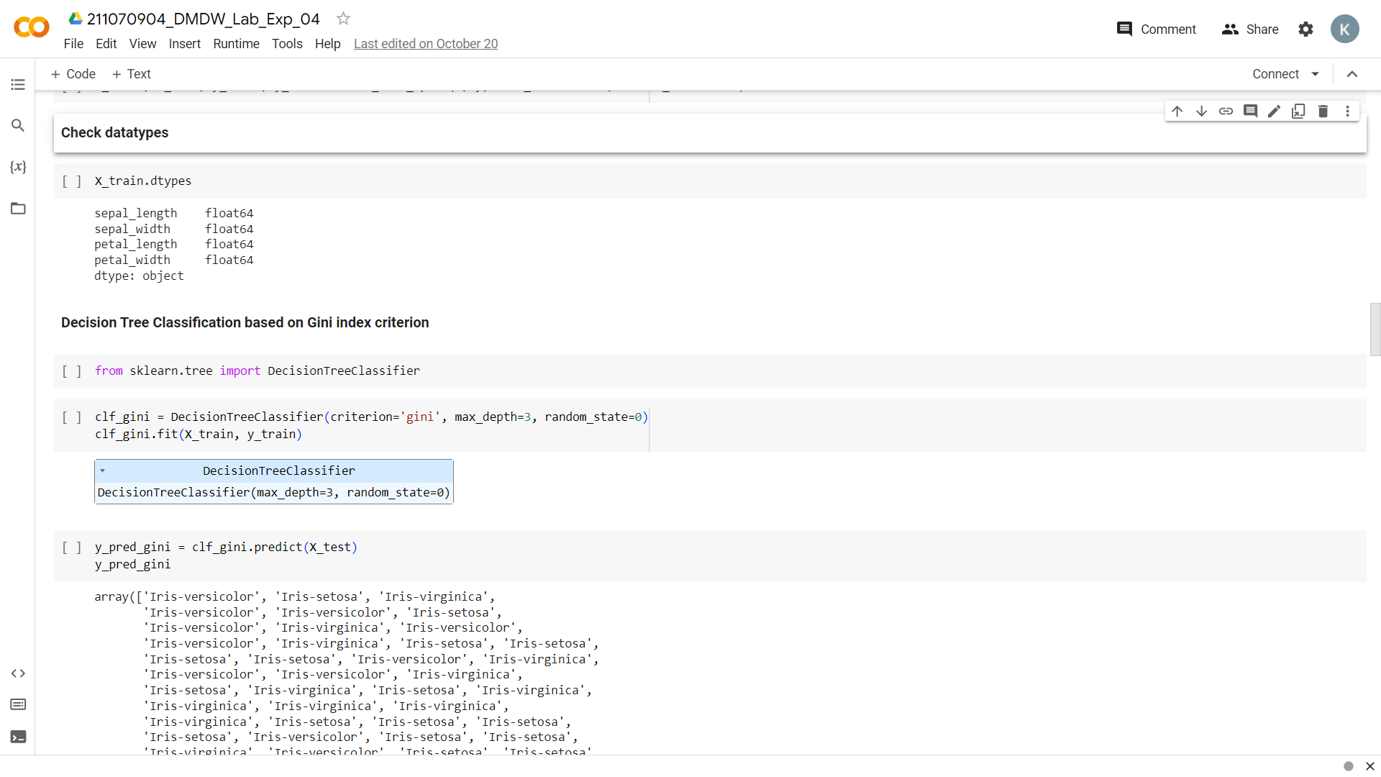

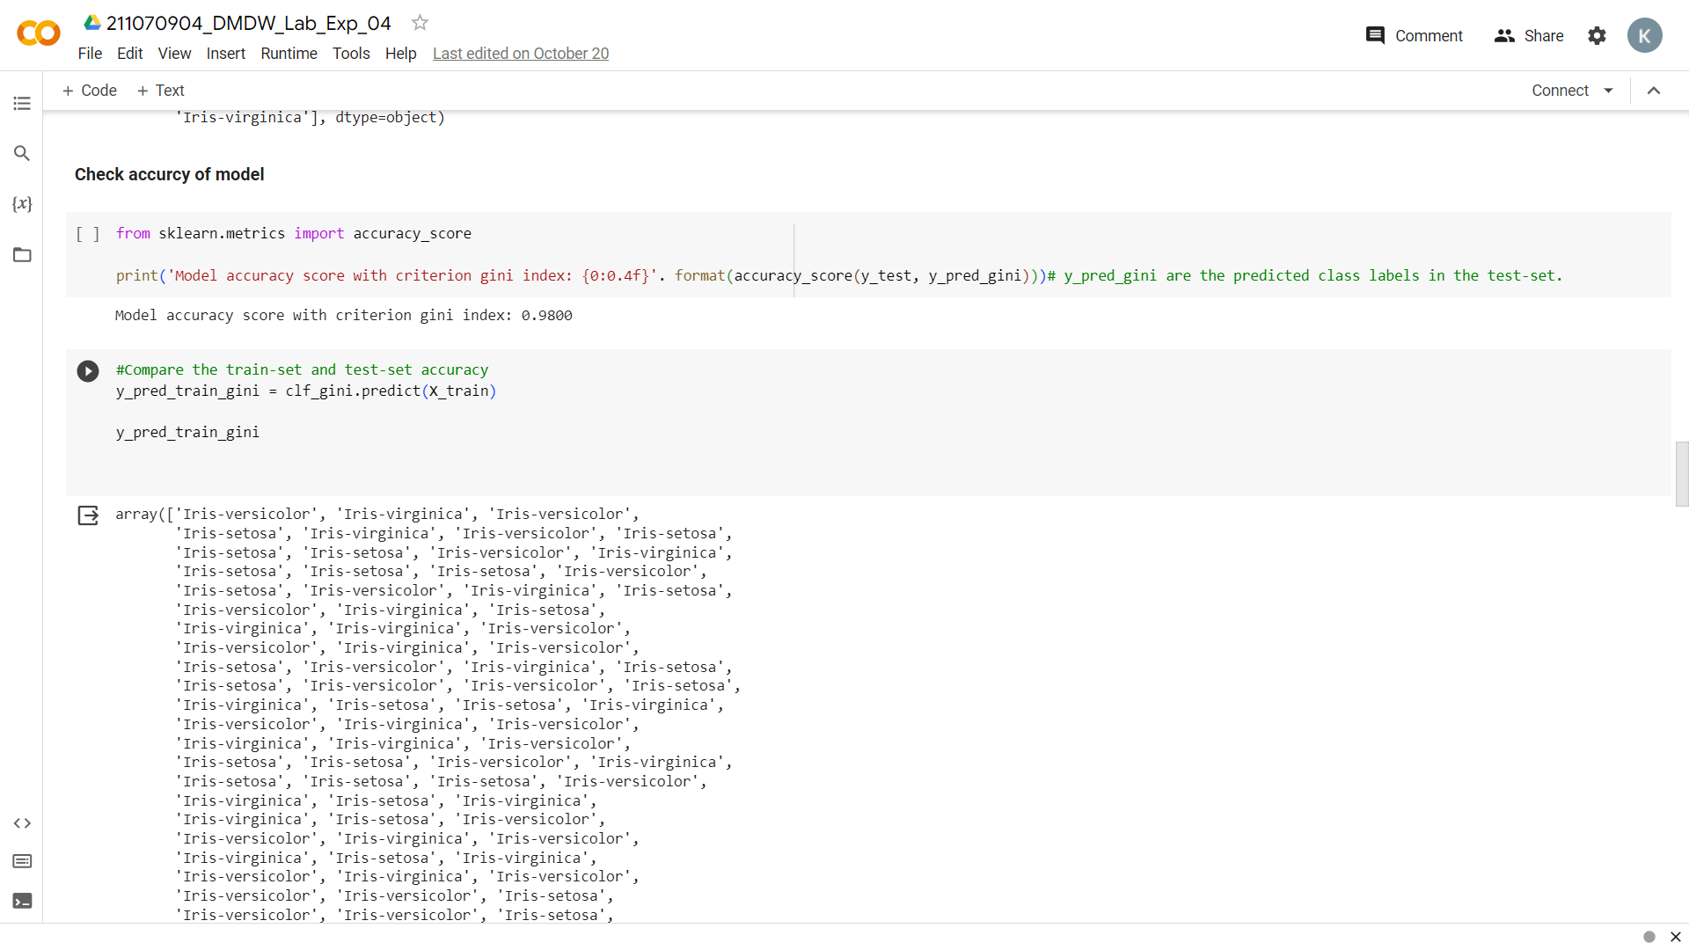

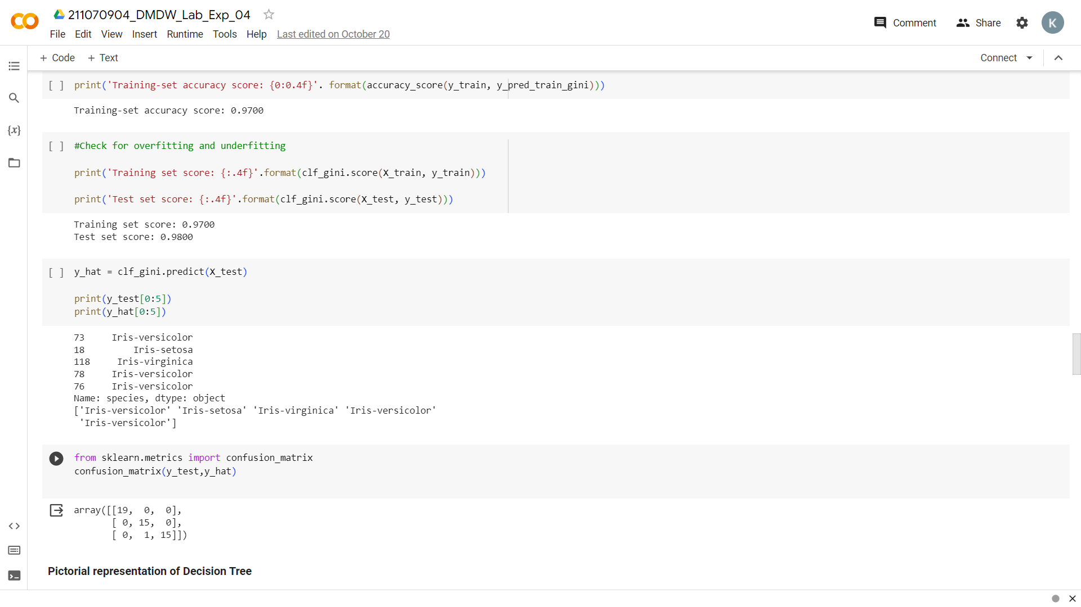

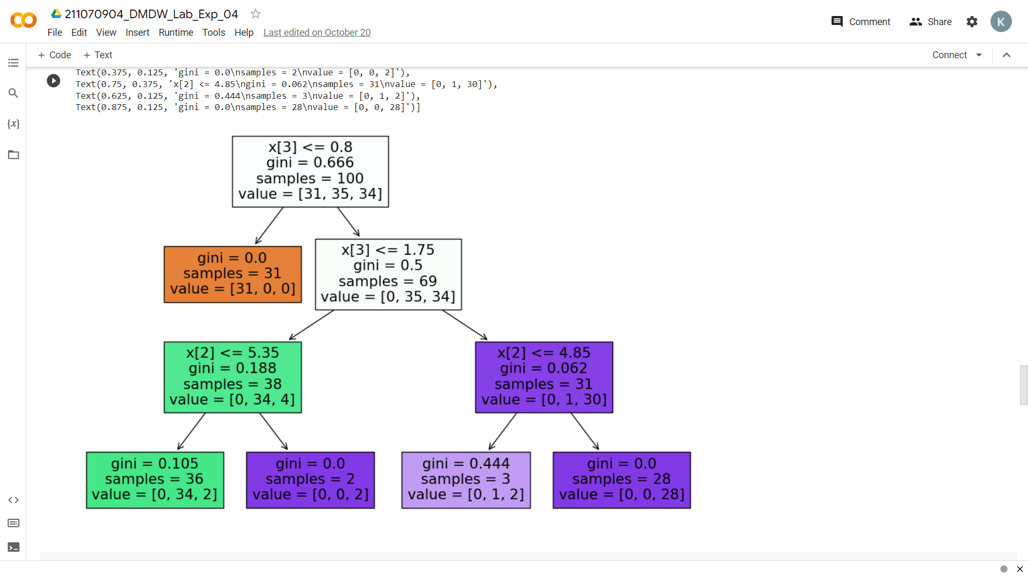

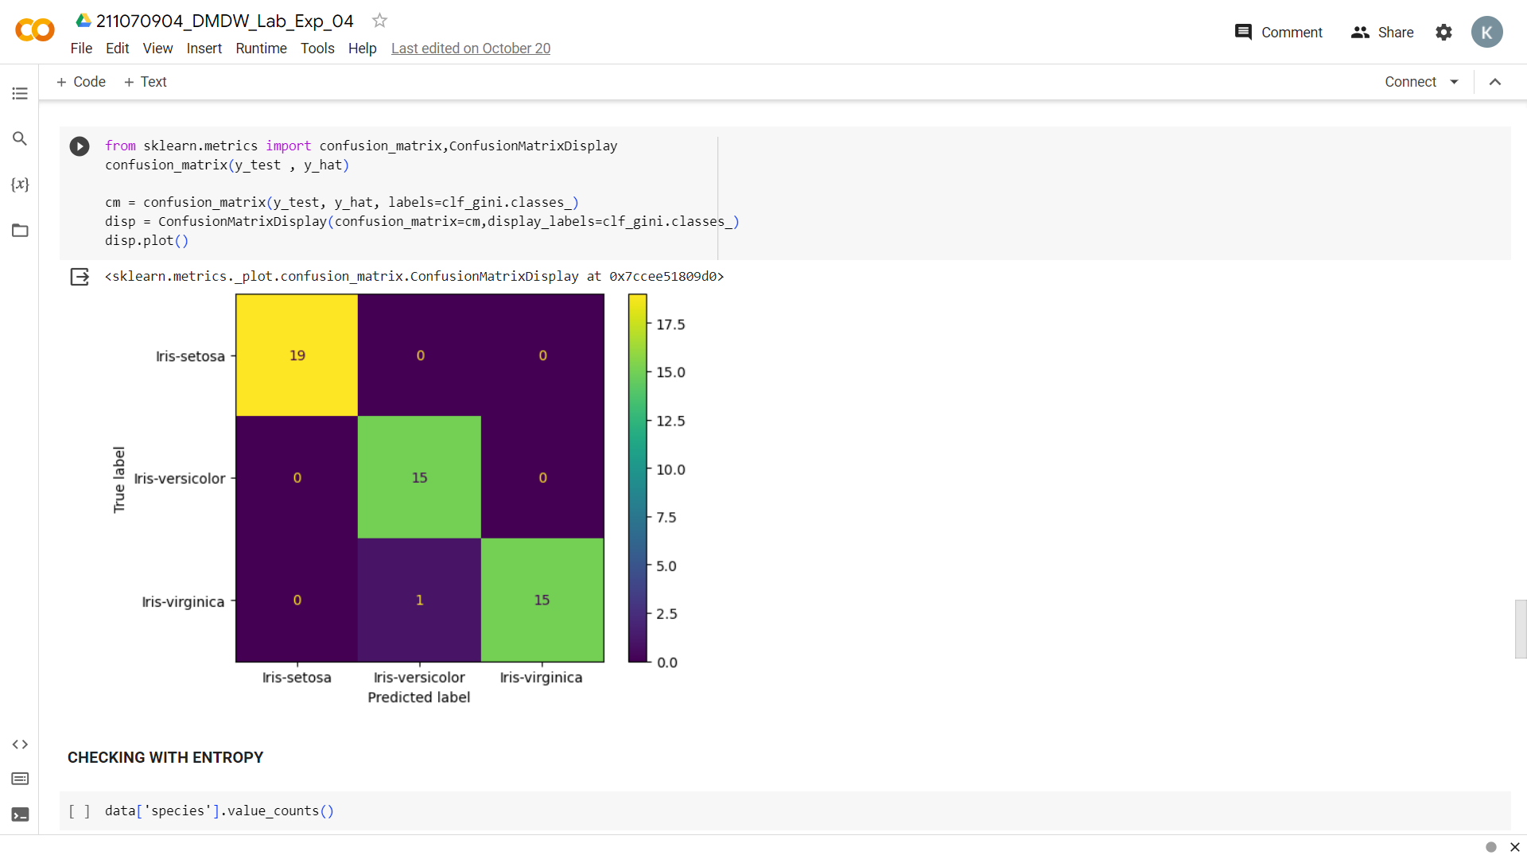

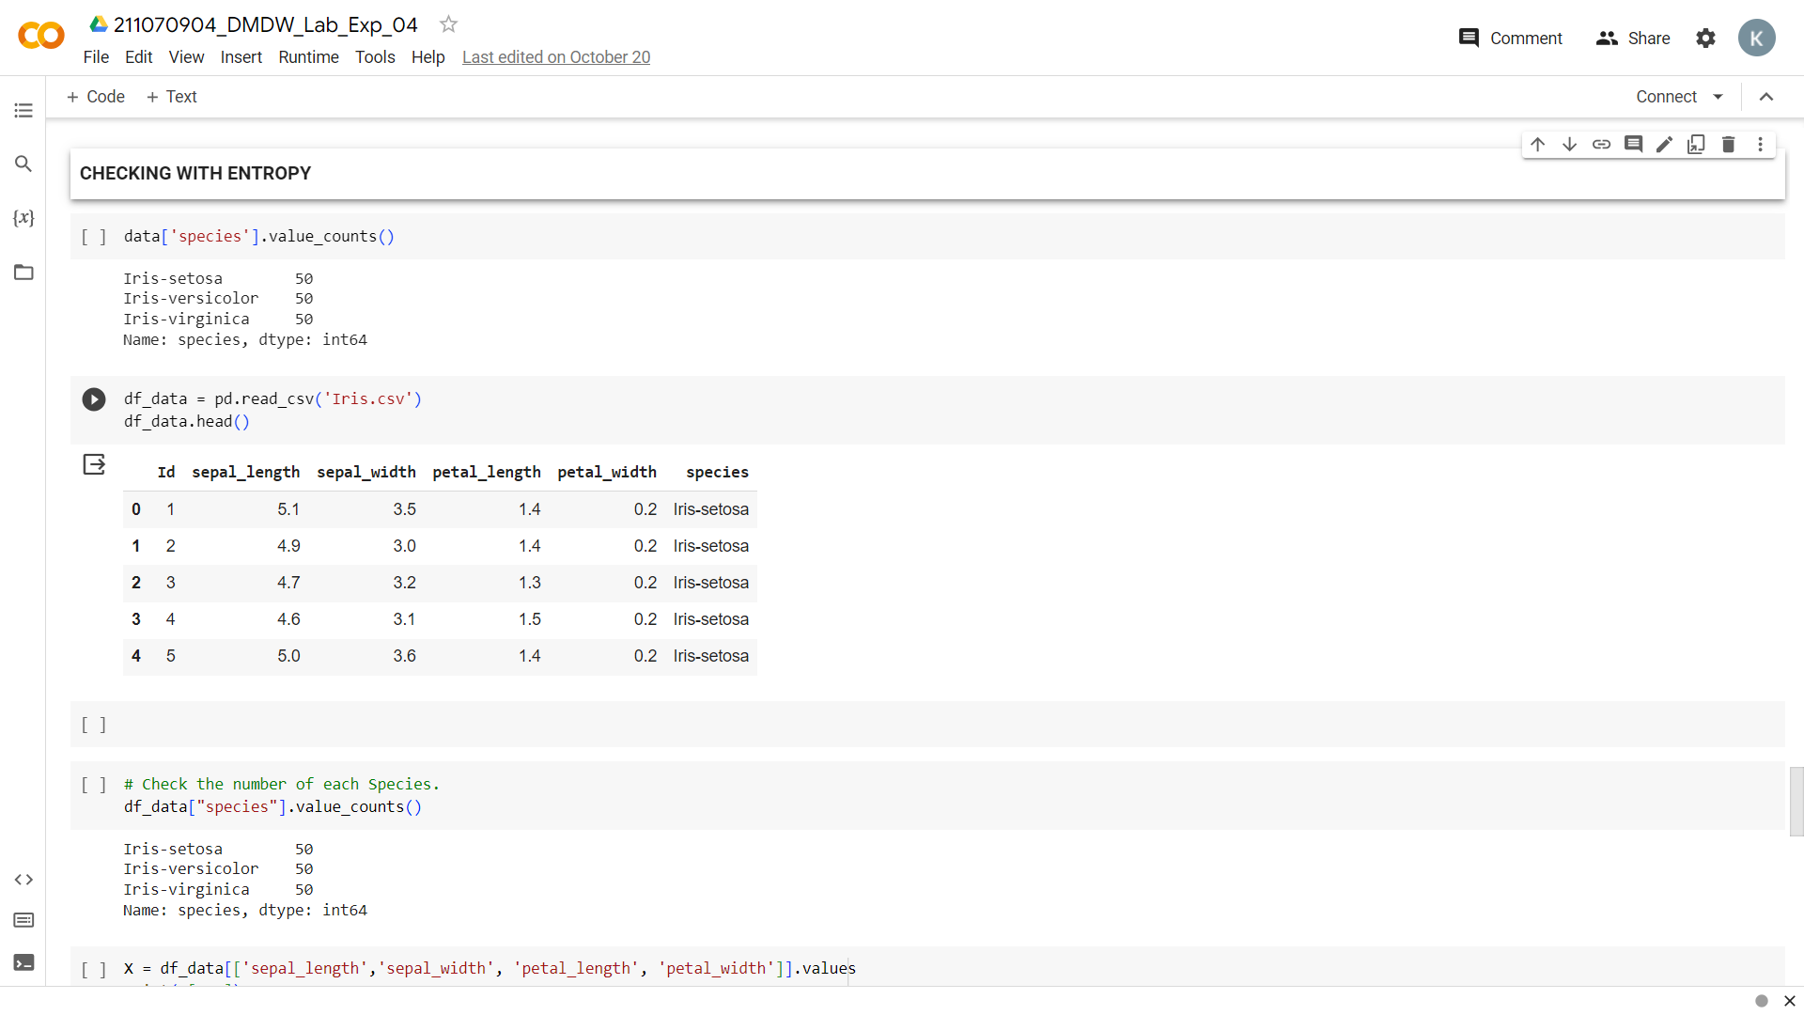



**2. Logistic Regression** **implementation:**

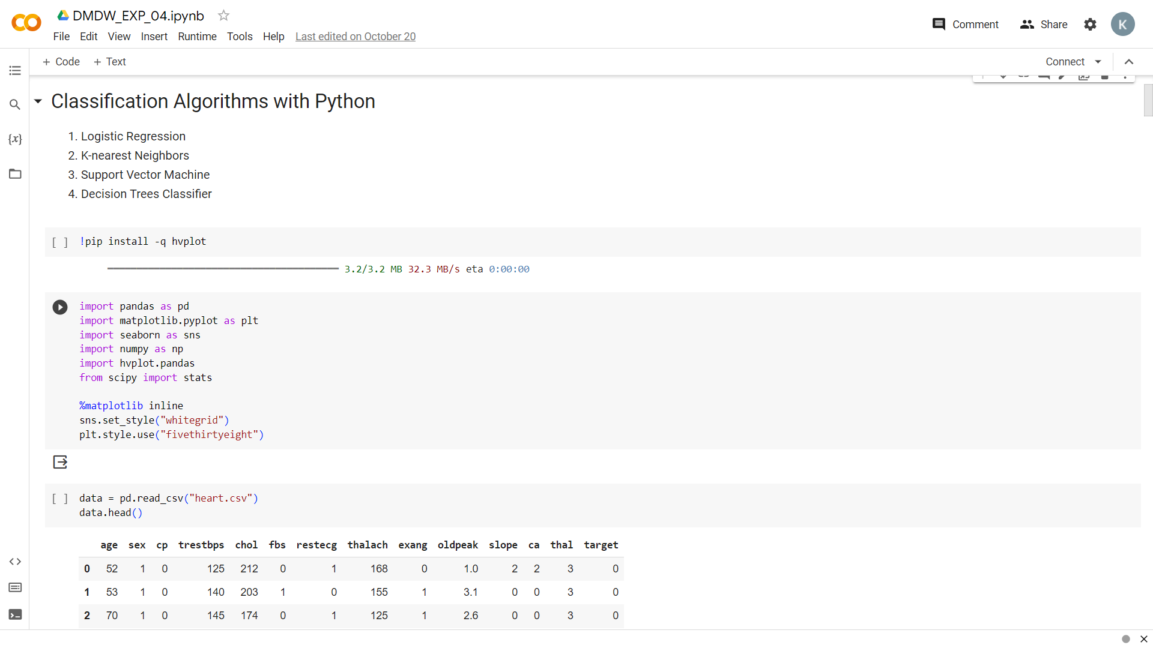

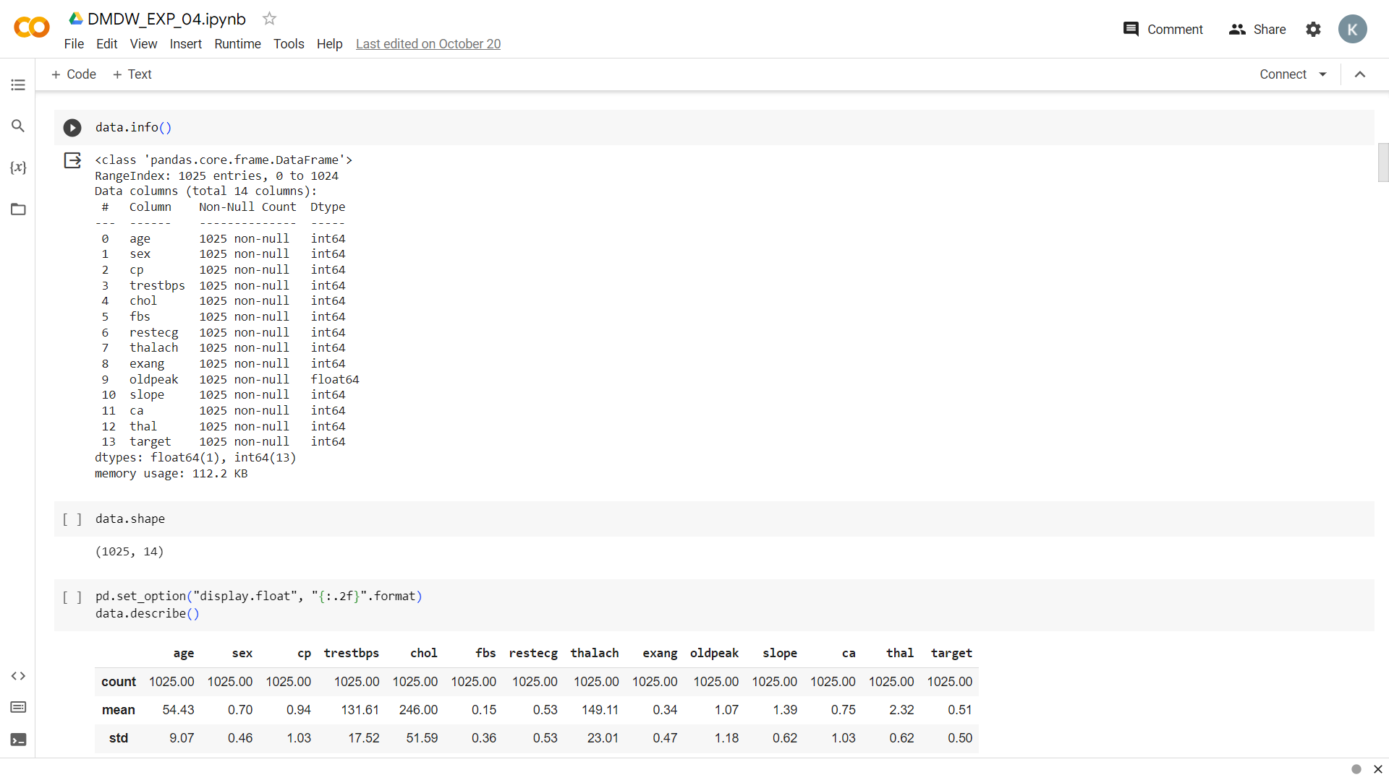

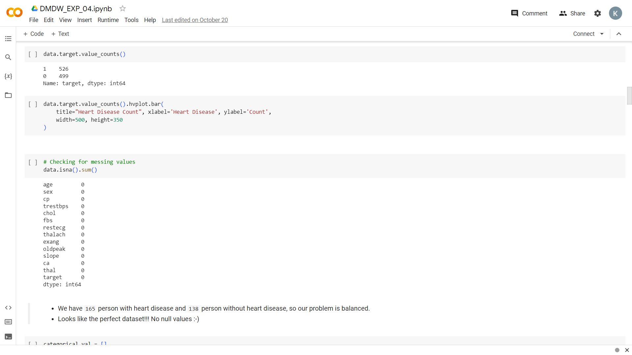

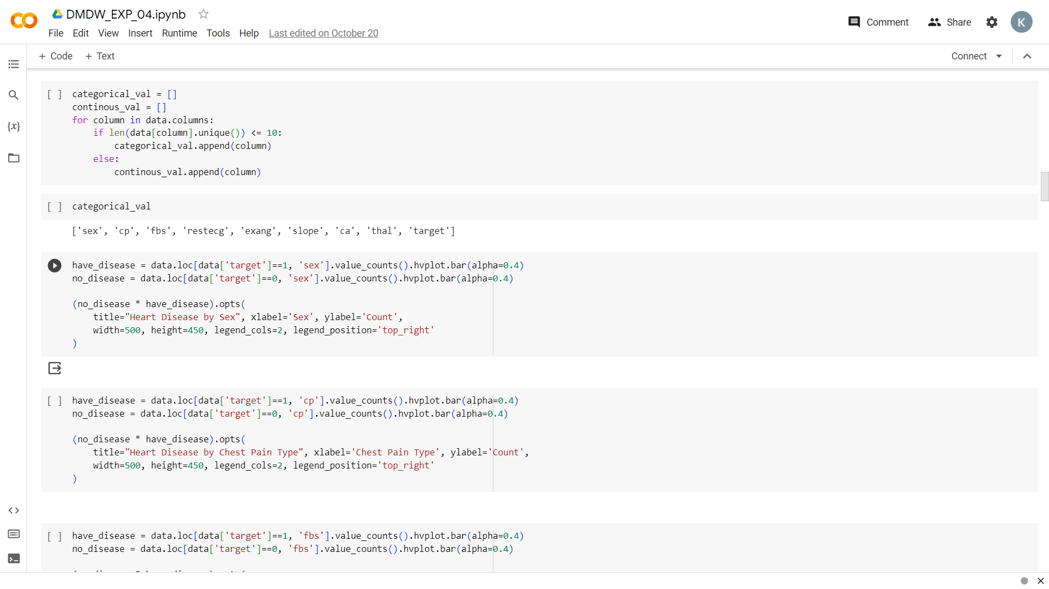

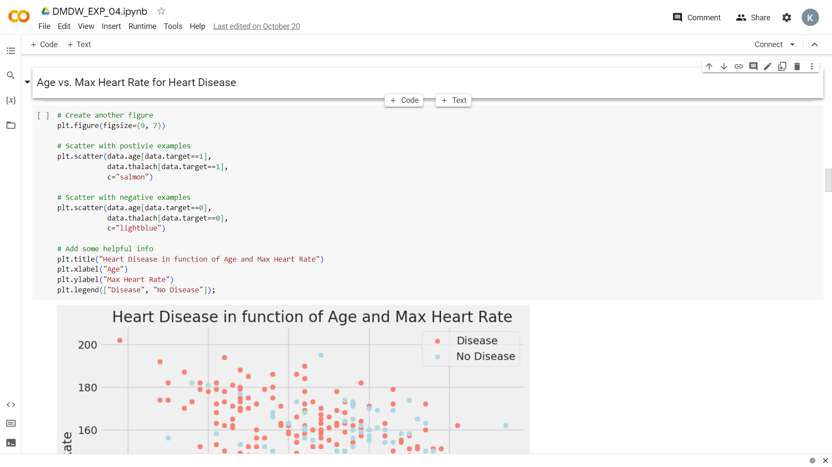

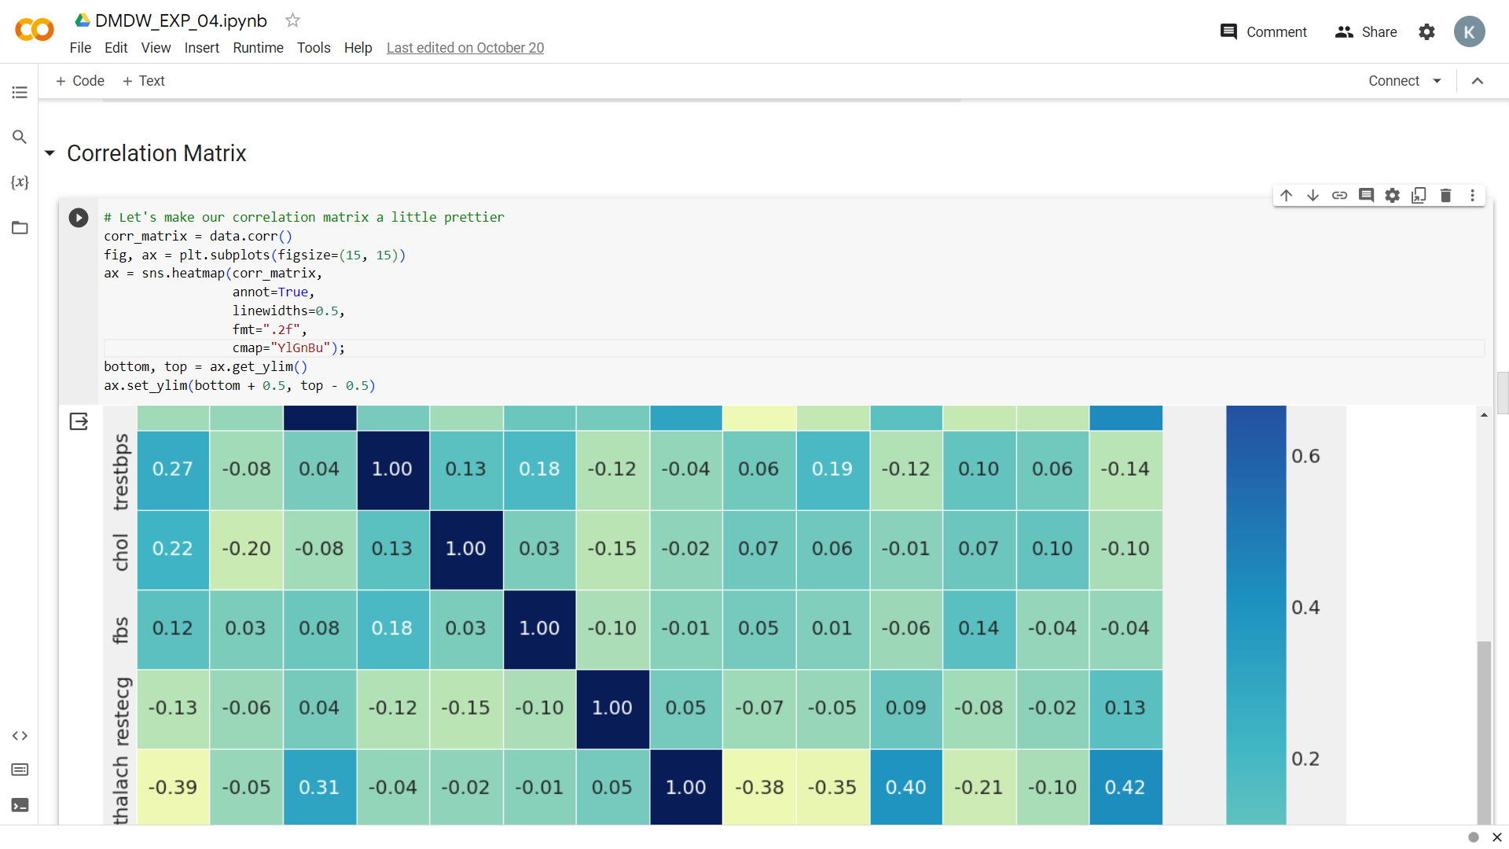

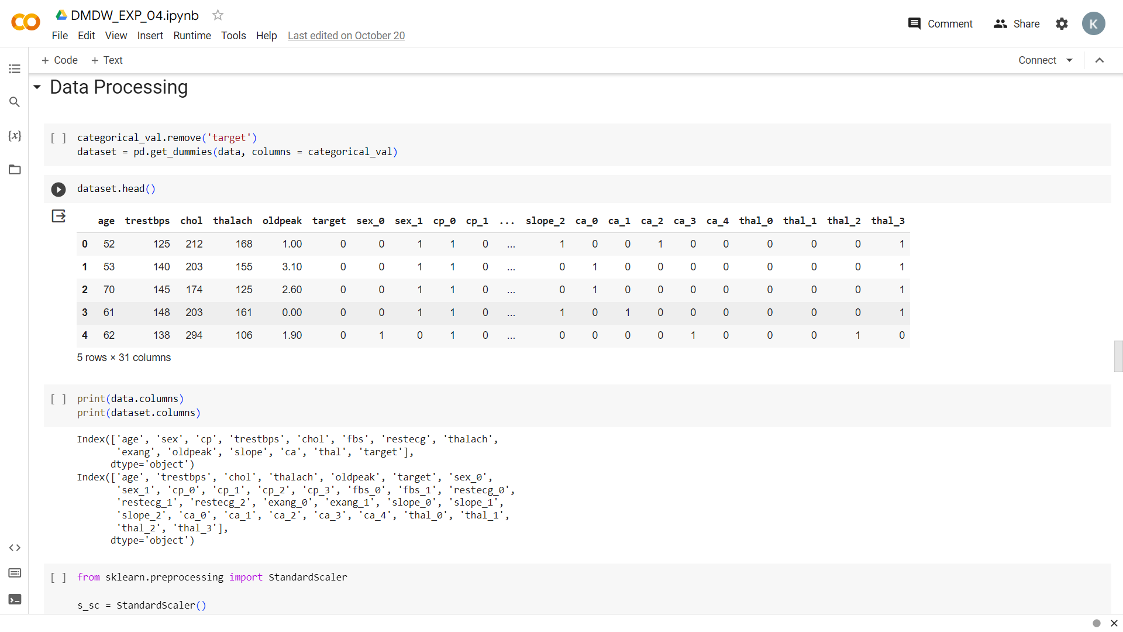

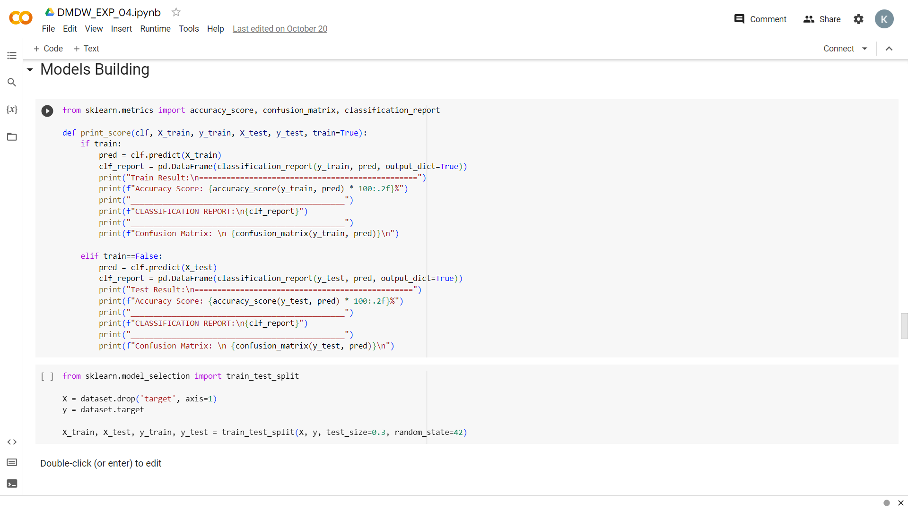

**2. Logistic Regression implementation:**

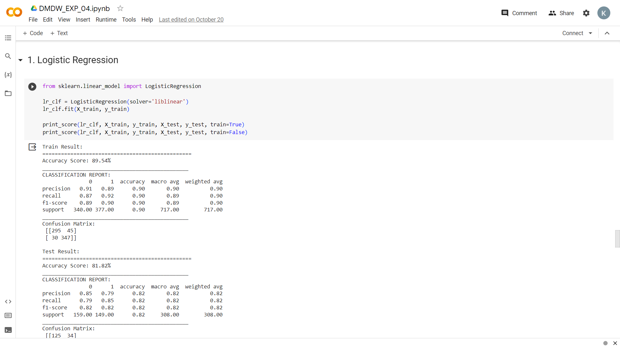

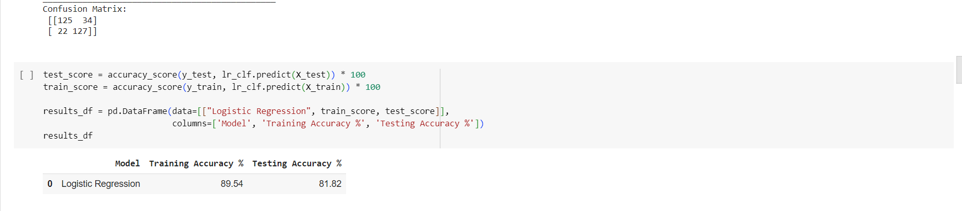

**3. KNN implementation:**

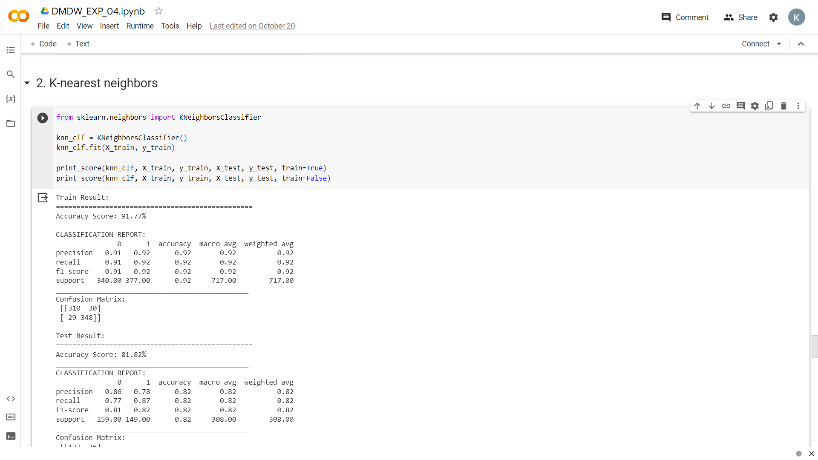

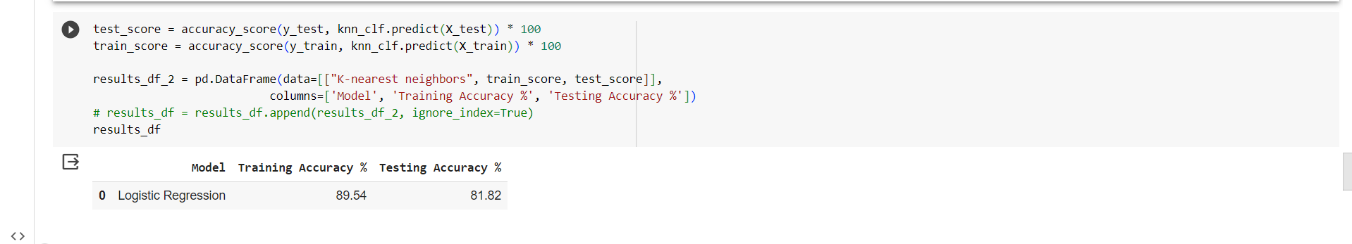

**4. SVM implementation:**

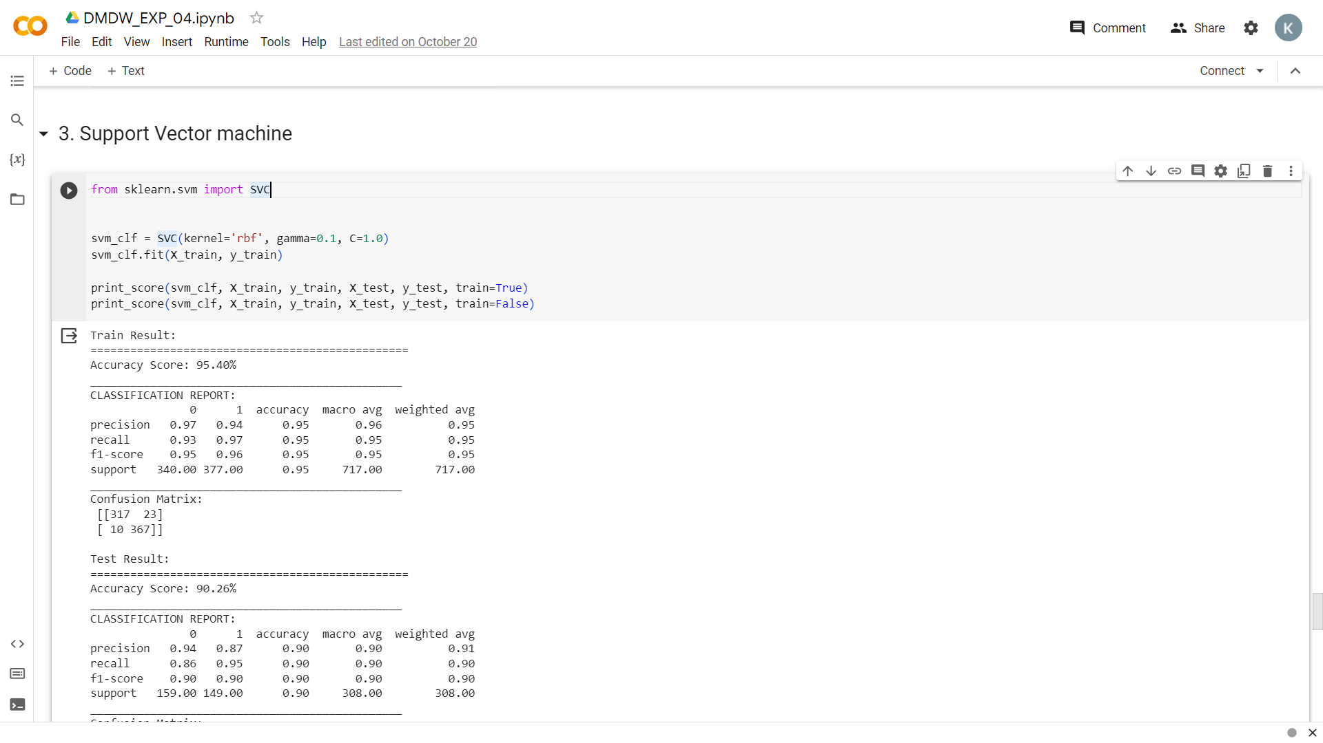

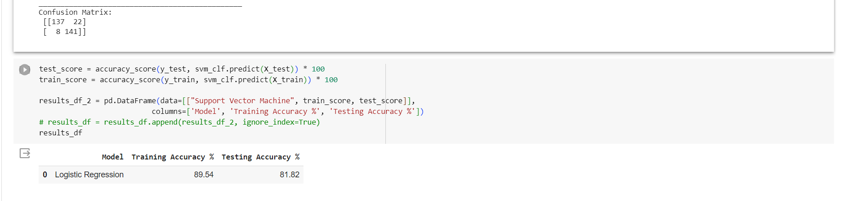

**5. Decision tree implementation heart disease:**

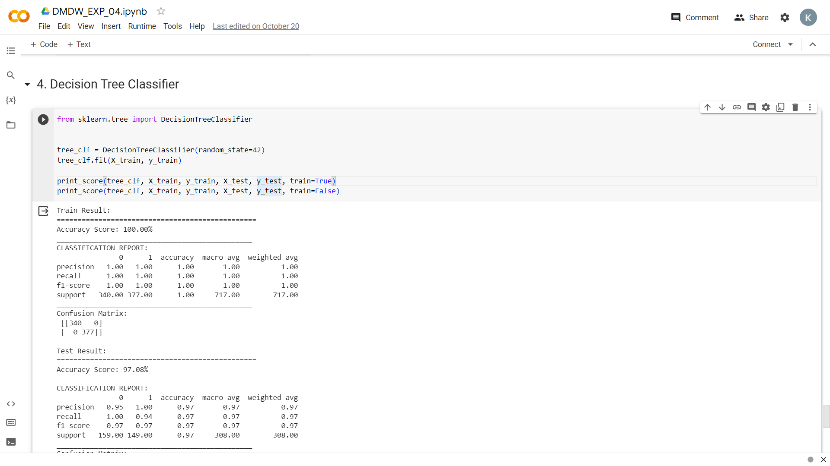

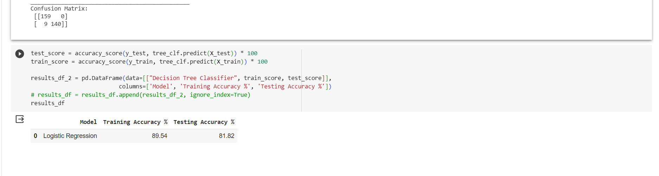

**Conclusion**:

In conclusion, a thorough study of classification algorithms, including decision trees, random forests, support vector machines, k-nearest neighbours, and naive Bayes, is essential for data scientists and machine learning practitioners. These algorithms offer a diverse toolkit for solving classification tasks across various domains. Understanding their characteristics, advantages, and best use cases enables practitioners to select and apply the most suitable algorithm to achieve accurate and interpretable results in real-world applications. Effective implementation also involves data preprocessing, feature engineering, model selection, and robust evaluation methods. In today's data-driven world, a deep understanding of classification algorithms is a foundational skill for extracting valuable insights and making informed decisions from data.